20. Record Level Securities (OWD), Manual Sharing - 22 March 2022

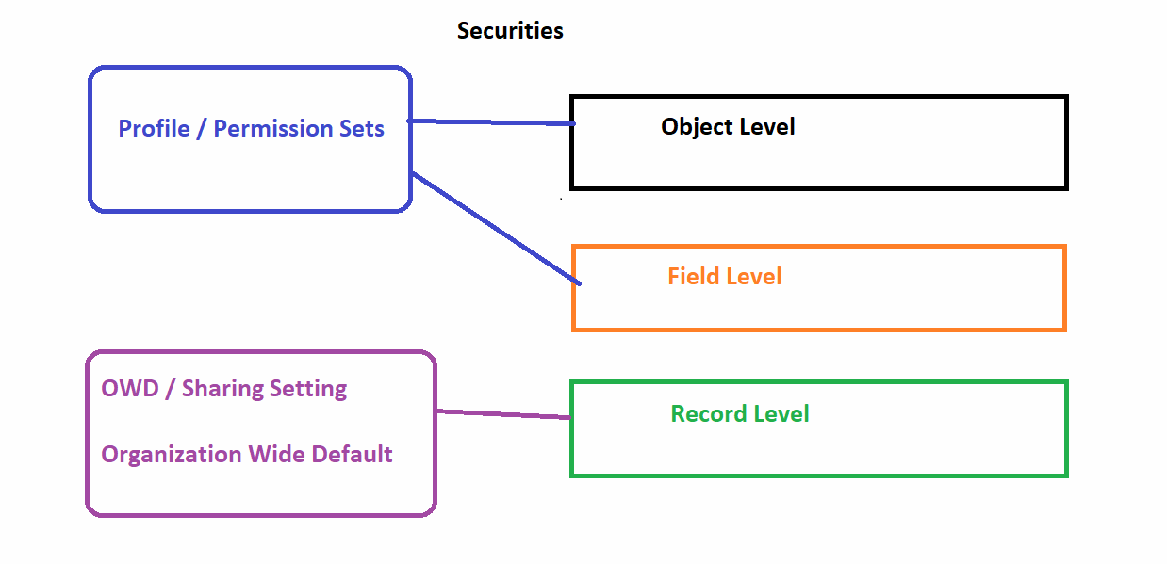

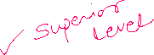

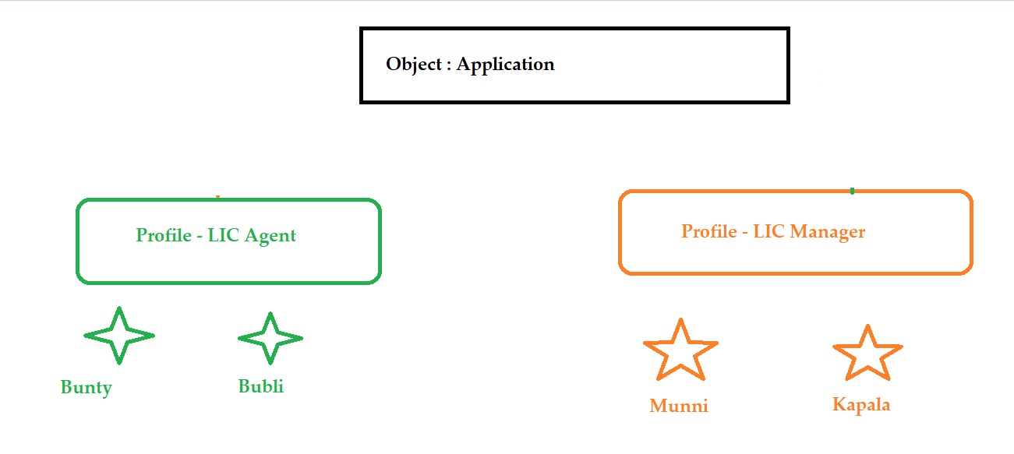

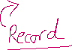

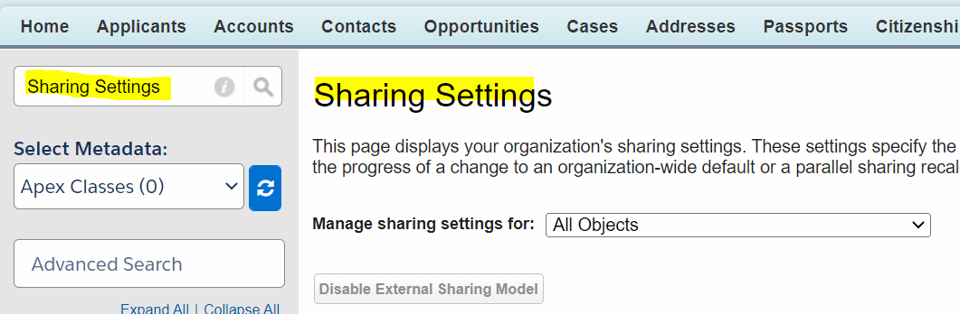

Record Level Access:

|  |  |
| --- | --- |
| 1. Private | User can see the records created by him / owned by him / Shared With him. |
| 2. Public Read Only | User can see the records of another User but in Read Only Form. |
| 3. Public Read/Write | User can see the records of another User and can read and edit. |

|  |  |
| --- | --- |
| 1. Private | User can see the records created by him / owned by him / Shared With him. |

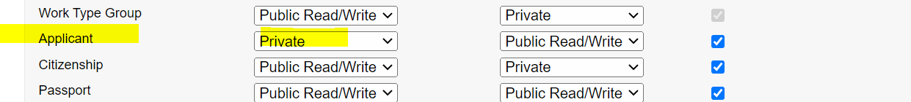

|  |  |
| --- | --- |
| 2. Public Read Only | User can see the records of another User but in Read Only Form. |

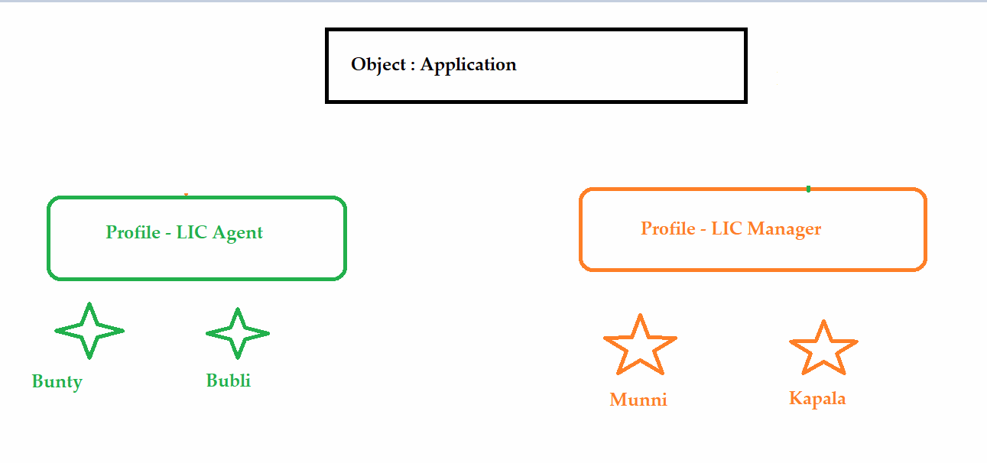

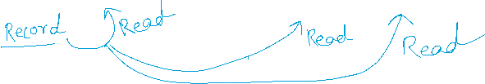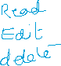



|  |  |
| --- | --- |
| 3. Public Read/Write | User can see the records of another User and can read and edit. |

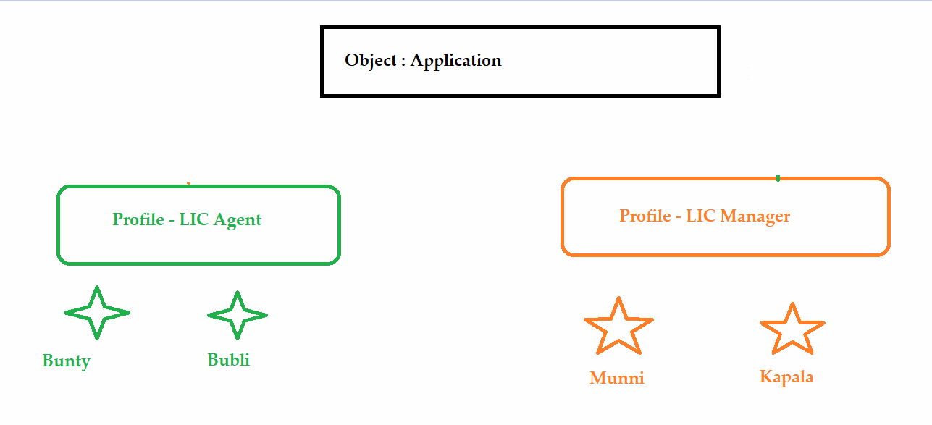

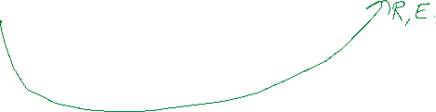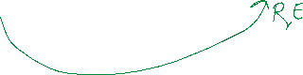

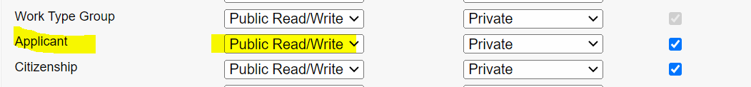

To check User as a “Shaktiman”.

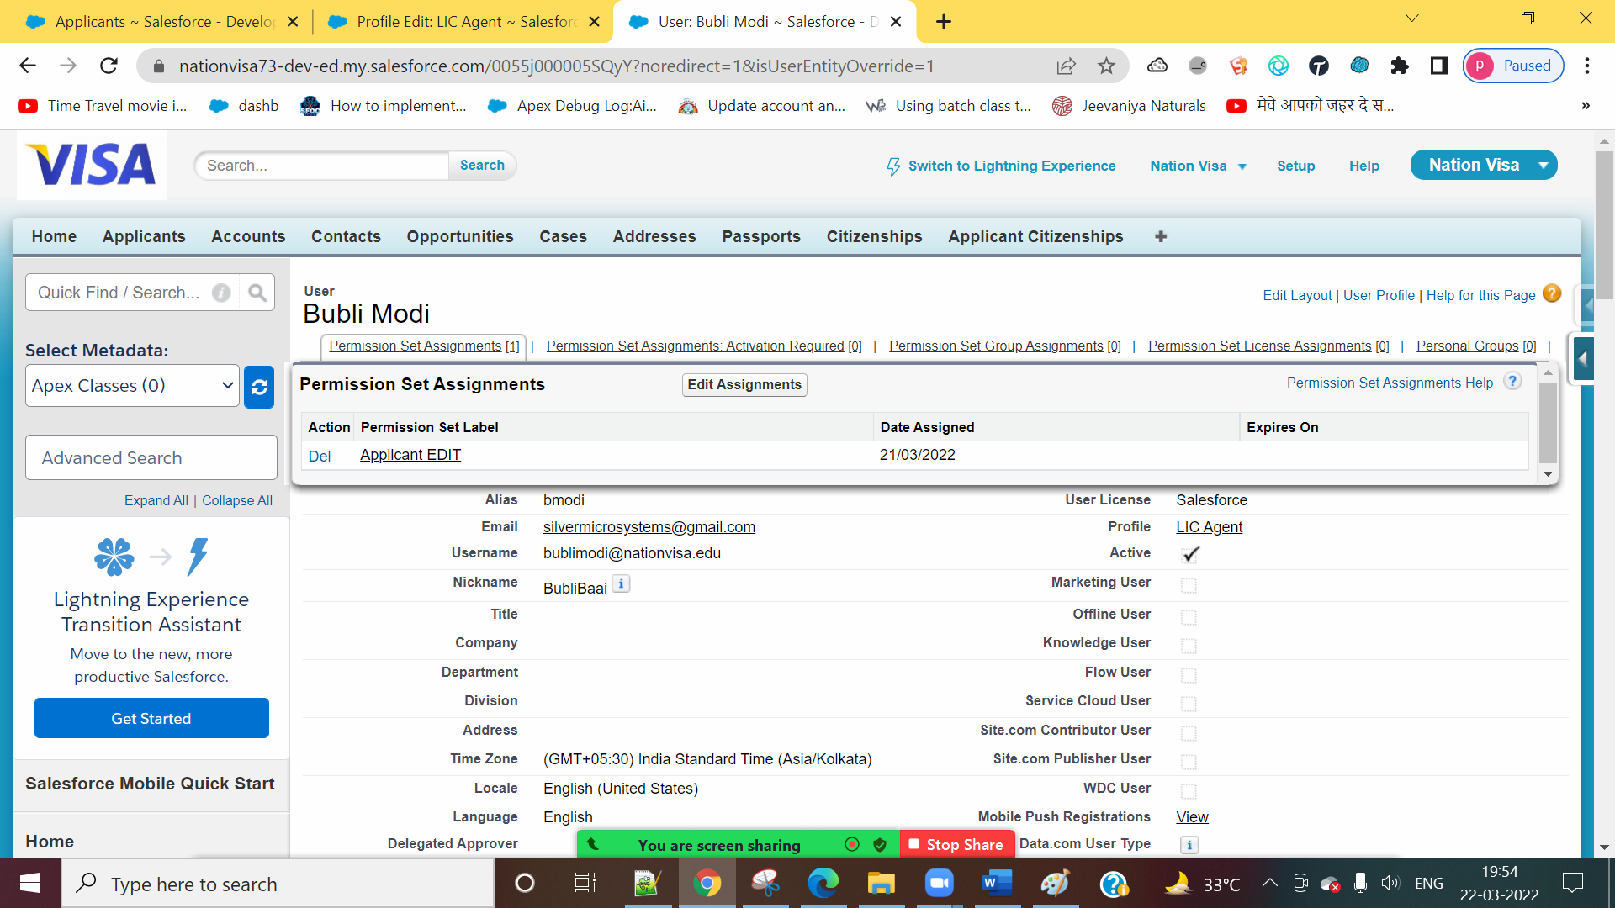



Applicant (OWD) = PRIVATE

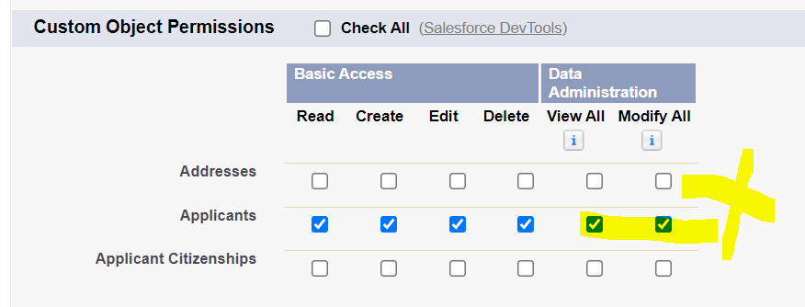

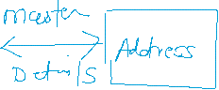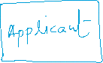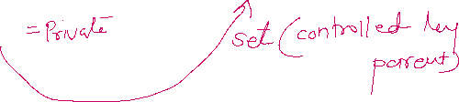

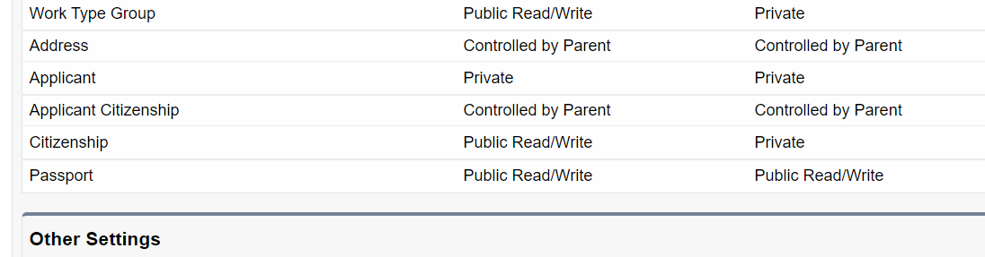



==============================================================================

Nandkishor‘s Issue

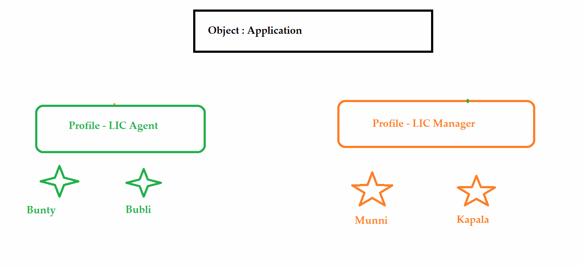

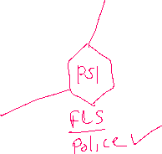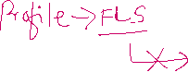

Record Sharing



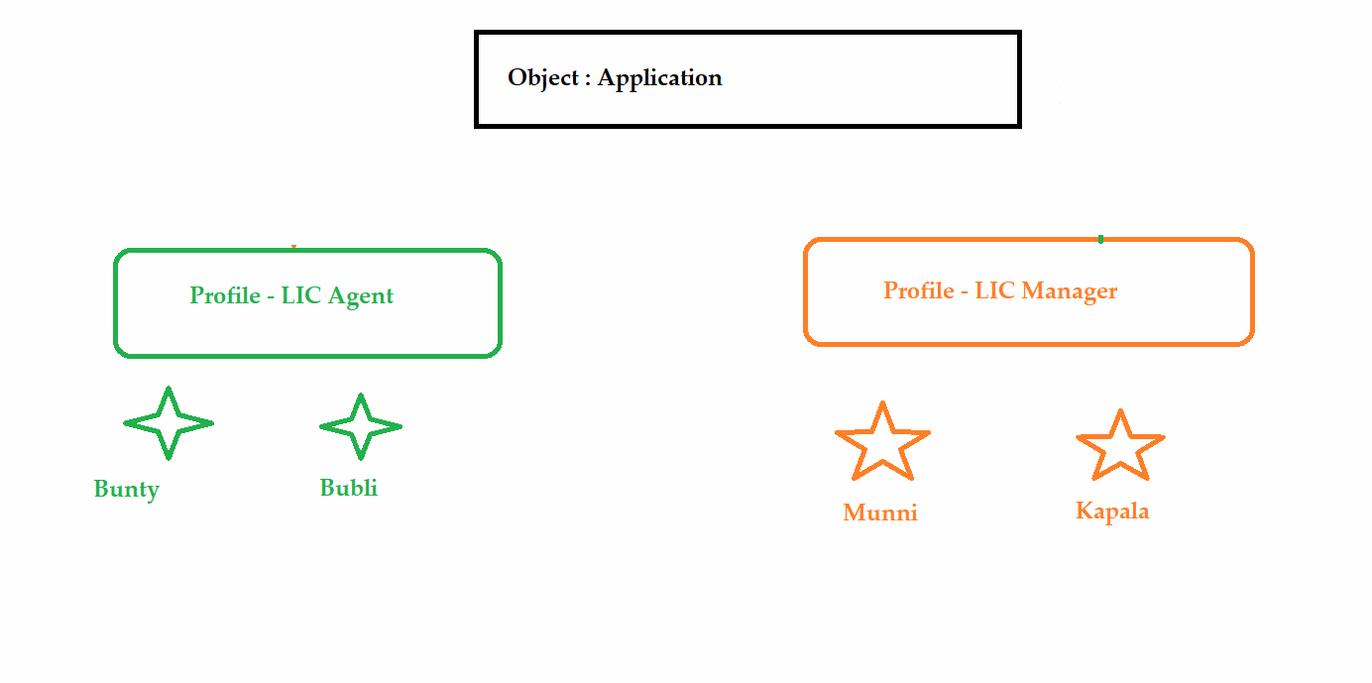

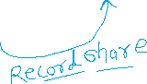

Record Sharing Types:

1] Manual Sharing

2] Sharing Rules (Automatic Sharing)

- Based on the Record Owner

- Based on the Criteria

3] Roles and Hierarchies

4] Apex Sharing (Coding)

1] Manual Sharing

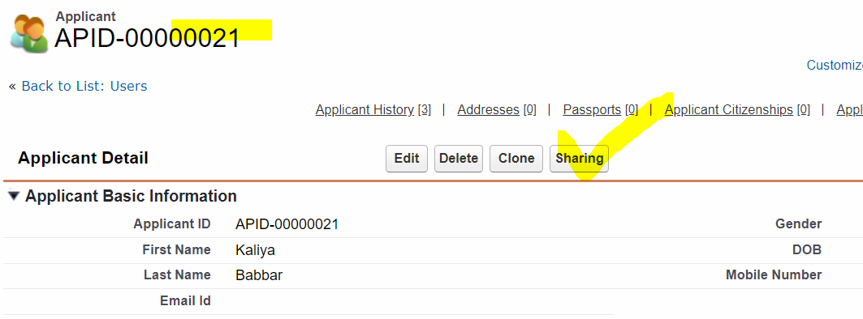

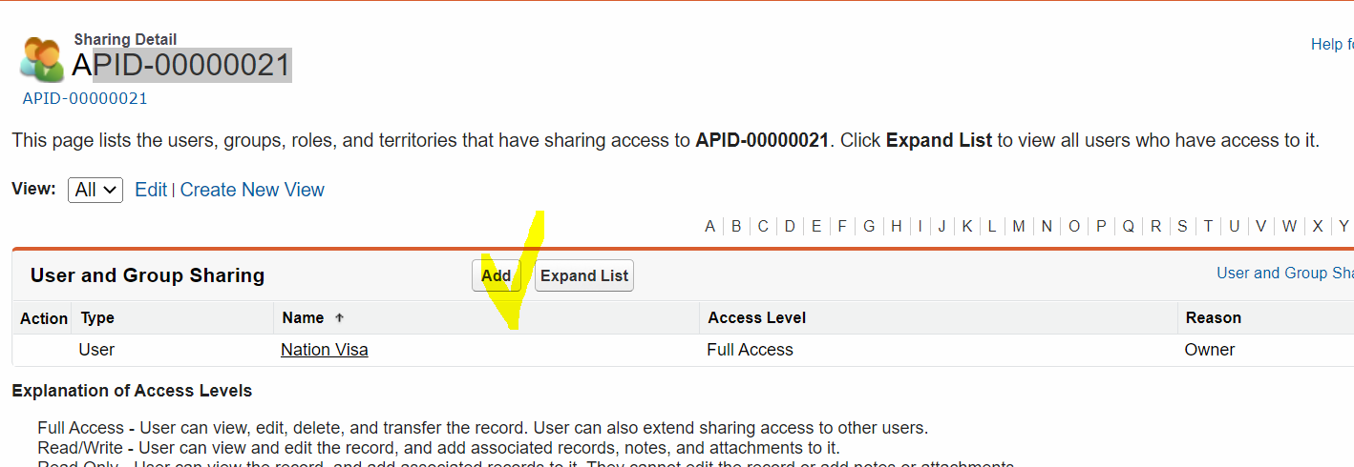

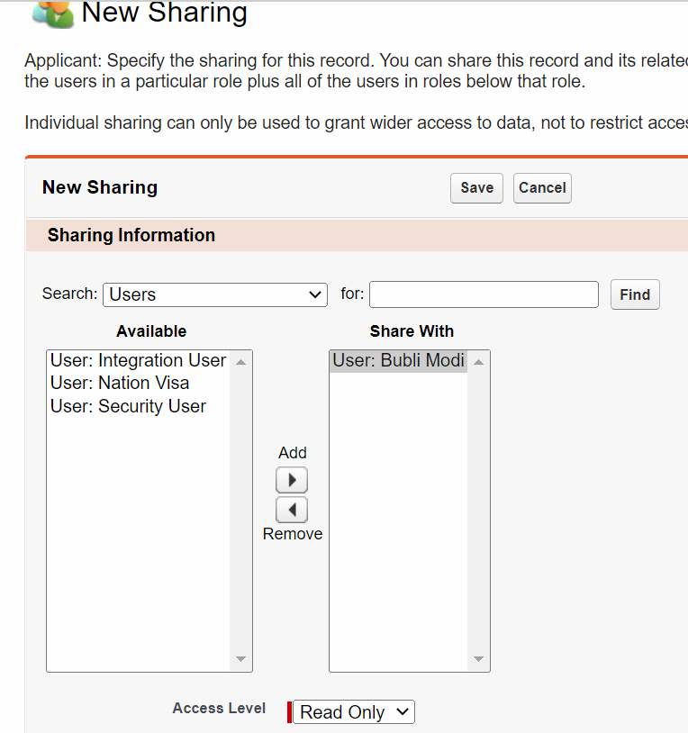

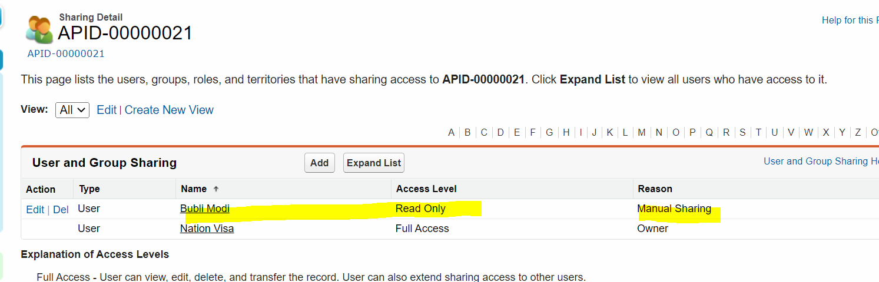



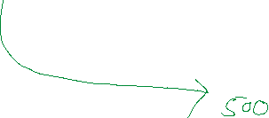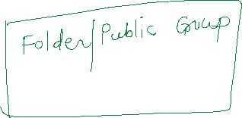

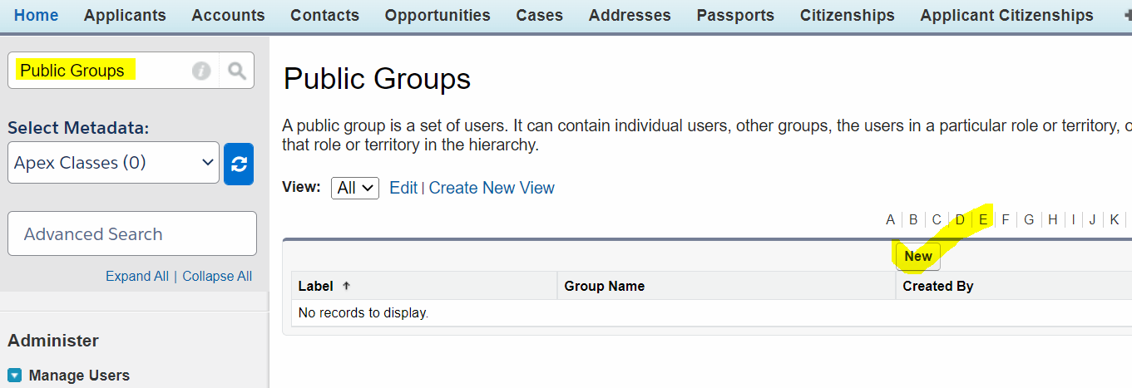

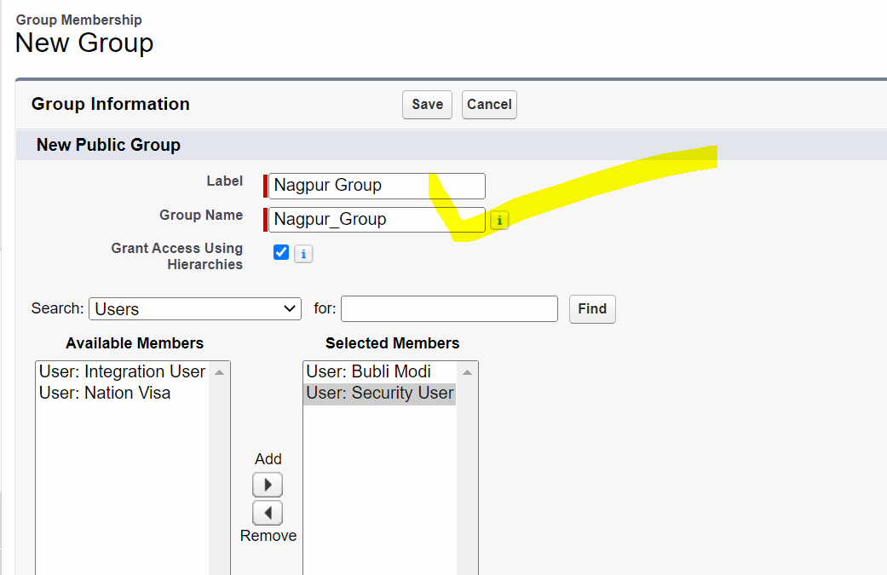

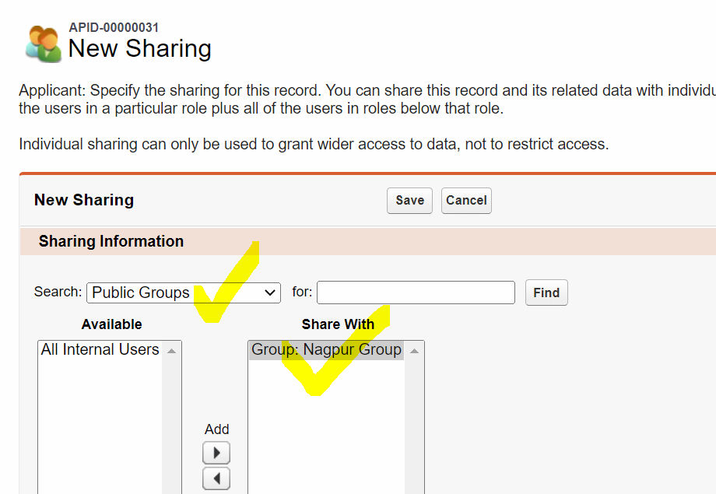



Rollup Summary (COUNT, SUM, MIN, MAX) 🡪 AVG (NOT)

AVG = SUM / COUNT

Applicant 🡪

COUNT = 5

SUM = 40000

AVG = 40000 / 5 = 8000

